“SUNSHINE FOLLOWS RAIN”/”AS THE RAIN PASSES”/”THE RAINBOW”
DAWSON DAWSON WATSON
1927

COMPILED BY SAM PEMBERTON
FEBRUARY-SEPTEMBER 2020

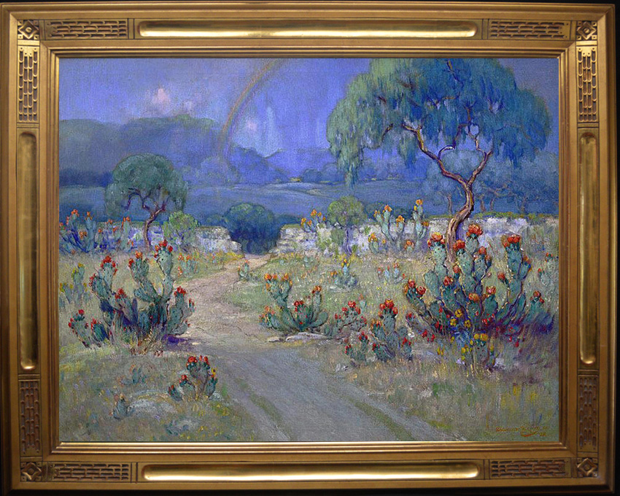

All pages, copyright 2020: Sam Pemberton
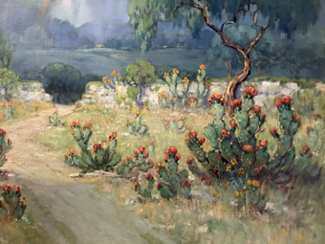

INDEX

1. The Process – Stream Of Consciousness.
2. Title Of Painting.
3. Provenance.
4. Exhibitions.
5. Possible Additional Exhibitions.
6. Galleries.
7. Books/Publications/ Newspaper Articles/Sources.
8. Other Information.
9. Proven Exhibitions - Analysis.
10. Possible Additional Exhibitions - Analysis.
11. Conclusion.

1. THE PROCESS-STREAM OF
CONCIOUSNESS.

It is a shame that owners of art don’t put provenance information on the back of the frame or painting itself. Personally, I consider it a requirement. A great painting, any painting for that matter that is historic or collectable, deserves to have history and context. If nothing else your name, date of purchase, and who you purchased it from.

I am not a researcher or an academic. I am simply a Texas Art collector. It is important to try to discover and preserve the history of significant paintings. Trying to find information on a 90-100 year old painting is an inexact science. When documenting provenance that far back in the past, there is often no photographic evidence. A researcher must rely on old catalogs, news articles, museum and library materials, and many other sorts of inexact sources. There is always gaps in the information. There are often judgment calls that have to be made. As a collector/researcher, my personal criteria for proving provenance or other history for a painting is that the information be accurate to a “probability”. Rarely will information be proven conclusively, especially when dealing with and documenting a painting that has been lost to history for nearly one hundred years.

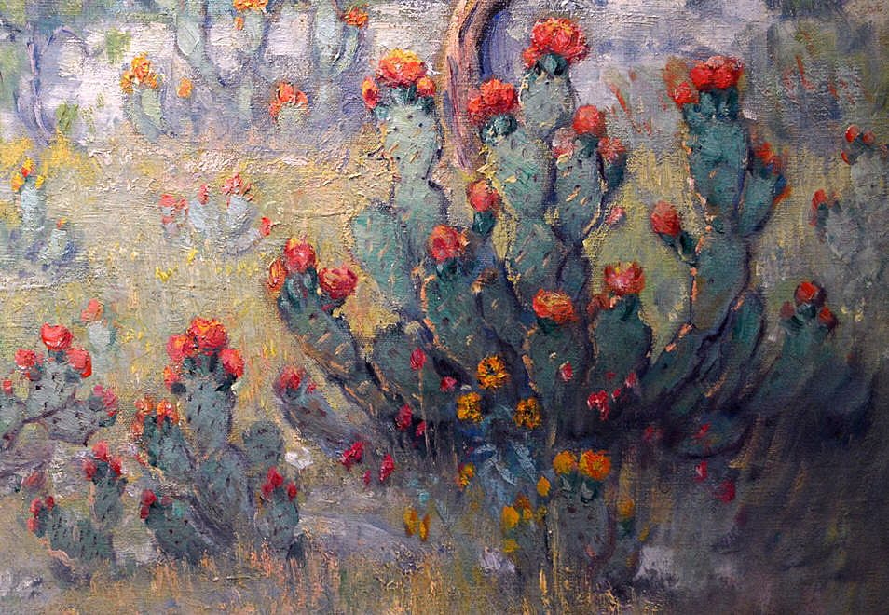

I probably know the subject painting better than anyone currently alive. I should, I stare at it every day from my desk. It is definitely big, thirty by forty inches, oil on canvas. Signed Dawson Watson, “27”, in the lower right corner.

A worn dirt road winds and slightly undulates through the sunlit field in the foreground. Large cactus clumps dot the field with the cactus flowers blooming in reds, oranges, and yellows. The colors combine and flow together in classic Dawson Watson fashion. The cactus composition and subject matter are exceptional, even for Dawson Watson.

Across the middle ground of the painting is the entrance wall and gate to the Gallagher Ranch, a common subject in many Dawson Watson bluebonnet and cactus paintings from the 1920’s and 1930’s. Behind the stone wall, a large field of bluebonnets stretches across the middle of the painting from side to side and to the tree line in the far distance. Openings under the distant trees show that there is another sunlit, field and a line of hills in the extreme distance.

A Hill Country spring thunderstorm hangs over the bluebonnet field with a subtle rainbow skirting the edge of the storm. The end of the rainbow extends down, fading into the bluebonnets.

I know every contour of this painting. The depth of the painting from front to back is exceptional and extreme. It glows. It is three dimensional, even in the poor lighting of my office. It is a Texas masterpiece.

I first saw the subject painting during a trip to Dallas to talk to David Dike about a painting that my wife had been interested in for a few years. It was a Herman Hansen watercolor that had escaped the attention of the Texas Art collectors that habituate the “David Dike Gallery” in the Museum District of Dallas. Being a Western painting, it was not really what the hard core Texas Art collectors favored.

It was August 14, 2014. David was in good form that day, taking us into his private office, pulling paintings for us to review and giving us his full personal attention.

After we had nailed down the purchase of the Hansen watercolor we browsed the gallery. As usual, the downstairs and upstairs was filled with Early Texas Art. We separated and I went up to look for hidden treasures stashed in the loft. There was a large, obvious, Dawson Watson on the wall . It was nice, but I already owned a large exceptional Dawson Watson cactus painting from 1927.

The next time I saw the painting was June 5, 2015 at “Fine Arts Of Texas” in San Antonio. We were meeting with Richard Plumley to pick up a Salinas painting that my sister had purchased. The three of us had a chance to study the Dawson Watson up close and in more detail that day.

My wife Karen was the first to appreciate that the subject painting might be significant, and that it was superior in composition and execution. It took us two years to actually make the purchase. Over that time I had a number of conversations with art conservator, Stashka Star, about wanting to purchase the painting but the timing was just not right. Stashka would tell me “that painting is waiting for you”, “it is meant to be yours”.

She was right. We purchased it in October 2019. Over the years the painting had grown on me to the point that I had to purchase it. Now, I look at that painting in minute detail every day. It is obviously a serious painting, but totally devoid of any provenance or background information.

I know the recent history of the painting from Richard Plumley. It was shopped around by an Oklahoma estate in the early 2000’s to Texas art dealers and collectors. At that time it was purchased by a Texas/California businessman for $65,000. Years later, in 2014, he decided to sell the painting since he was going to be out of the country on business for a number of years and he did not want to store it.

It was consigned to Richard Plumley in San Antonio. In April of 2014, Richard sent the painting to the “David Dike Fine Arts” in Dallas to be shown in their gallery on consignment. A year later, in April of 2015, it returned to San Antonio to Richard Plumley. It was eventually purchased by James H. Clement Jr, Chairman Of the Board of the King Ranch and a King Ranch heir.

That was it. That was all that I, or anyone else, knew about this painting.

I wondered, where had it been for the last ninety three years? It was a large exhibition size painting done in Dawson Watson’s prime. Surely it had been exhibited, but there was no record or history.

What was it called? Everything about that painting was apparently unknown. It bothered me that it was a forgotten painting. I considered it a masterpiece, but with no provenance, history, or even a name, it was lost to history.

The Corona virus pandemic of 2020, I would not know anything about the history of the painting if the virus had not happened. When the virus hit in mid February 2020 everything came to a halt. Shelter in place, at home, was the norm. I was left with plenty of time to kill and like many art collectors I decided to focus on art. So, I decided to try to research the history of this painting.

What did I have to start with? I knew it was painted in 1927 by Dawson Dawson Watson. Early in his most important period, 1926 to 1935. It is on a big 30 X 40 canvas which was his preferred canvas size for his most important exhibition paintings. All the Davis Competition paintings were 30 x 40. It is an exhibition quality painting. That’s it. Well, of course, I also knew the subject matter.

I started by spending many hours searching and reading online. I looked for anything to do with Dawson Watson that might have some comment or information about a painting from 1927 with a rainbow. I looked everywhere online, in articles, books, libraries, research sites, photographs, anything. At the end….I had nothing…….a total dead end.

A few weeks before the virus shutdown I had been told by Marshall Meece, a friend and fellow Early Texas Art collector, about a three volume set of books by Vic Roper, “Texas Artists And Artisans 1718-1959”. By random chance those books arrived in the mail just as I exhausted my internet search. As soon as I got the books home, I turned to the Dawson Dawson Watson entry. There, was the longest, most extensive, exhibition and museum history of any publication that I knew of for Dawson Dawson Watson. I read every listing from start to finish. One stood out and motivated me to continue my search…..”Texas Artists Exhibition”, “Nashville Museum Of Art”, ‘The Rainbow”, 1927”. In fact, “The Rainbow” had won a prize in the 1927 exhibition.

Energized by that reference, I started over, searching every combination of words and every possible source for anything to do with Dawson Watson and a Nashville exhibition in 1927 with a painting called “The Rainbow”. After all, how many similar paintings could there be in 1927? This must be my painting. But again, nothing but a dead end.

Late one evening as I was randomly doing some internet searches. I decided to see what newspapers were in existence in Nashville in 1927. There might be archives that I could access from the year 1927. Up popped a number of search results from “The Tennessean”, Nashville, Tennessee referencing an exhibition of Texas paintings in Nashville in 1927. I found three articles from The Tennessean”, April 8, 10, and 25, in 1927. The articles stated that in 1927 Texas artists were showing in the “Carnegie Library Gallery” in Nashville. The article, dated April 8, 1927, in “The Tennessean”, mentioned:

“Notable examples among the Texas group now on display are the following numbers; 52, showing a rainbow hovering over a field of harebells….”.

Interesting but, what are harebells? They are bluebells or bluebonnets. This vague description could be describing the middle ground of my painting where the rainbow hangs over and subtly extends down into a field of bluebonnets.

I also found an article documenting that number 52 won first prize and was a crowd favorite. But nothing to clarify whether or not this was my painting.

So, here I was, another standstill, another dead end.

As I have done throughout this search, I returned to the Vic Roper book. There was a listing of a Dawson Watson painting in the “Stark Museum Of Art” called “Landscape with Rainbow”.

I thought this might be my painting. What if my painting had previously been in the Stark collection? What if the museum had extensive documentation on the painting? After all, how many Dawson Watson paintings could there be with a rainbow?

I was stopped before I could get started. Normally I would just call the museum staff and have them email me any information they might have on the painting. But, the museum was closed for the virus. It was not possible to search their collection online.

As I continued to flail around online, one of my searches turned up a book on the art collection of the “Stark Museum of Art”. So, I ordered the book. This was one of five reference books that I ordered during my research. Four days later the book arrived in the mail and sure enough, there was a painting called “Landscape With Rainbow” by Dawson Watson listed in the collection.

Unfortunately, the painting in the book was small, 12 x 10. A few weeks later, I got an email from a Stark Museum employee offering to help me. She found out for me from the museum records that the painting was still in the museum collection. It could not be my painting. Another dead end.

Ok, I would go right to the source. I would call Vic Roper and see what documentation he might have on “The Rainbow”. We had a nice chat about his books and the painting, but he had nothing for me. Another dead end.

I was now into this “little” research project by four weeks and at least fifty to seventy five hours of time. When I started this failing project weeks earlier, I had intended to look at the digital photos taken by Stashka Star during her conservation work on the painting. I had looked at the photos a few times in the past and had not seen anything significant. I kept putting it off as a waste of time. But, being at yet another dead end, with nothing else to do other than just give up, I got out the disc of conservation photos.

There was nothing helpful in the conservation report, the name of the painting was blank. There was one photo of the back of the painting before conservation. I pulled that photo up at 5x magnification. A slow review of the entire back of the frame turned up nothing. I than went over the entire back of the canvas inch by inch, at various magnifications, nothing. I started going around the edge of the canvas focusing on the area where the canvas is tacked down to the stretcher. In the upper left corner, there it was, three faint words and some numbers or other information that was marked over.

I was focused on the name “The Rainbow”. I spent two or three days trying to make out those words and trying to come up with some way to make the words say “The Rainbow”. It was like trying to fit a size twelve foot into a size two shoe. There was just no way I could make the words say “The Rainbow” or even contain the word “rainbow”.

So once again, back to the Vic Roper book. I wanted to review the name of every painting in his exhibition and museum lists. Especially those from 1927 to 1935. I studied the words on the back of that canvas for three days. I finally realized that the first letter of that third word was a large cursive “R”. It became apparent that the last word of the three was “Rain”. I did a quick search and review of English Cursive writing, especially the capital letters. Using the Cursive alphabet, the middle word looked like it began with an “F”. That opened up the second word to me, “Follows”. The first word quickly became apparent once I identified that the first letter was an old style English Cursive “S”. “Sunshine Follows Rain”.

I called Stashka and asked her to review the original digital photos. Her reply a day later, it says “Sunshine Follows Rain”. In the meantime, I had gone back to the Vic Roper book. If my memory was right there was something in there with a similar name. There it was…..”Sunshine Follows Rain”, Waco Cotton Palace Exhibition, 1929, 1930.

I was elated. I had found the name of the painting and two exhibitions in 1929 and 1930. If I found nothing else, I was very satisfied. What I had found was more than I had ever imagined finding.

At that point I decided to email Richard Plumley to see if he had noticed the name on the back of the painting and if he had any information. For the next ten to fifteen days we emailed back and forth every day discussing my search and the results. He provided much valuable feedback, support, and suggestions in my hunt for information. He was not aware of the name on the back of the painting. Later I found out that David Dike was also not aware of the name on the back of the painting when he had it in his gallery.

Deep into my continuing search, Richard emailed me that he had started a trial subscription to Newspapers.com. I had already signed up myself but had not done any searching except for the Nashville articles. So, I began searching Newspapers.com under “Sunshine Follows Rain”. Another Dead end.

I than decided to broaden my search and do a general search for anything and everything to do with Dawson Watson for the years 1927 to 1935 in every newspaper in the country. I began to scan and read every article that came up in my many search variations.

Articles started to appear for exhibitions in 1927 and 1928 in Kansas City, San Antonio, Tucson, El Paso, and Abilene. As I was reading the articles I came across one that mentioned “The Rainbow”. It was in the “El Paso Evening Post”, El Paso, Texas, March 6, 1928. The article mentions a painting called “The Rainbow” that was a crowd favorite in an El Paso exhibition. The description states:

“Mrs. Dawson Watson said she had “a finger in the pie” in “The Rainbow”, a favorite in the exhibition and a prize-winner in the Nashville 1928 (1927) exhibition. It is a picture of a rainbow ending in a bed of bluebonnets. The rainbow was changed to her liking”.

After many days of continued research, reading, and searching for every news article written about Dawson Watson in the years 1927 to 1935, I came across a pivotal El Paso article. It was from the “El Paso Herald”, El Paso, Texas, March 5, 1928. I had learned that you had to read the entire article. Often some important nugget of information would be buried deep in an article. Far down the page, I come across mention of a painting that was an exact description for my painting. BUT, it is not called “The Rainbow” or “Sunshine Follows Rain”. The reporter called it “As the Rain Passes”. The description was perfect:

“Perhaps the best composition in the group is exhibit #29, called “As The Rain Passes”. It is representative of the country 20 miles from San Antonio, showing cactus and a sunlit field in the foreground with a passing shower in the background edged with a rainbow”.

In addition the article mentioned that this exhibition of 50 paintings was previously shown in Kansas City, San Antonio, and Tucson. My old standby, the Vic Roper book had verification of some of these exhibitions. There could be little doubt from the exact description that this was my painting. I did not have a photograph, but I now had a detailed, exact description, that was an identical match to my painting.

My search continued with a focus on newspaper articles under all those various cities and the name Dawson Watson. I began to find numerous articles for each city documenting the exhibitions, times, dates, and the attendance by Dawson Watson and his wife at many of the exhibitions.

Richard Plumley sent me the exhibition catalog published by The Witte Museum for a December 1927 to January 1928 exhibition of 50 paintings, monotypes, and engravings. This time period is a match for the San Antonio exhibition listed in numerous newspaper articles. Many of the newspaper articles mention the exhibition having 50 paintings, monotypes, and engravings matching the Witte Catalog. It became very obvious that I was seeing a traveling exhibition that toured numerous cities between November of 1927 and into 1928. I now had confirmation of exhibitions in Kansas City, San Antonio, Tucson, El Paso, and Abilene. In addition I had the 1929 and 1930 exhibitions at the Waco Cotton Palace Exposition.

After exhausting the news articles on the traveling exhibition, I decide to search for further information on the Waco Cotton palace exhibitions, in 1929 and 1930. The Vic Roper book lists “Sunshine Follows Rain” as being in those exhibitions. There was nothing in any of the vintage newspapers for Waco.

I got the idea to search the “Baylor University Library” for Cotton Palace records. Since Baylor University is in Waco, I figured their library might contain city and other local records. It did not take long to find a listing for Cotton Palace records in the Baylor University archive. Of course, they were closed for the virus, but I was able to pull up the data online in digital form and there in Box 4, was listed “Cotton Palace Art Catalogs” for 1929 and 1930. Just what I needed, but the library was closed for the Covid virus.

After emailing a librarian and being passed from person to person, I finally got to the librarian for the Cotton Palace collection. She agreed to go in to the closed library and review the boxes for me. The 1929 catalog was missing, but the 1930 catalog showed that Dawson Watson exhibited “Sunshine Follows Rain” in 1930 as part of a group of paintings sent to the Cotton Palace Exposition by the “Pabst Galleries” in San Antonio. This was definite confirmation of the Cotton Palace Exposition exhibition.

I thought I had reached the end of my research when I got lucky again. The latest “TACO” (“Texas Art Collectors Organization”, Dallas, Texas) newsletter showed up in my email inbox. At the bottom of the letter there was mention of a number of research resources that I had not thought of. SMU Library system, “The Portal To Texas History”, and “The Handbook Of Texas”.

So I started again, searching these potential new sources for any mention of the various cities and exhibitions that I had previously identified. In “The Portal To Texas History” I found reference to a scrapbook from the “Abilene Women’s Art Forum” with materials from 1922 to the 1950’s. I opened up the scrapbook and searched inside for Dawson Watson. My review produced a 1935 exhibition catalog, where Mrs. C. M. Caldwell loaned a painting, “As The Rain Passes”, to an exhibition in Abilene in 1935.

The final piece of my research was the discovery of a number of articles in the “St Louis Globe-Democrat” from September 11, 1927 that filled in the history of the organization of the traveling exhibition that ran from late 1927 to early 1928:

“Now he (Dawson Watson) is going back to direct the 1928 contest (Davis Competition), and to open his art school in San Antonio. He came to St Louis, partly to make up his traveling exhibition, which Robert Holland, director of the Kansas City Art Institute, has invited for the month of November………..”

Now it made sense why Kansas City was the first city to host the exhibition. The work to organize and put together the art for the exhibition was done by Dawson Dawson Watson in St Louis, Missouri.

The September 11, 1927 article in the St Louis Globe-Democrat continues:

“We want to tell St Louis something about the Temple Of Art in Tucson, Arizona, where these same pictures are to be shown after the middle of January. In the interim they will go to San Antonio for a tremendous one-man exhibition to include about twenty pictures that were bought last spring by discriminating San Antonians, which will be lent by their owners for the occasion. That will be the December event in the spacious galleries of the San Antonio Association for the Promotion of Art and Culture, an organization that has none of the pink tea flavor commonly associated with such enterprise.”

The end of my search finally occurred in late August of 2020. By than I had received the archive materials that I had requested from the Witte Museum. My research was much more comprehensive and extensive than I have outlined above. In the course of my research I also communicated with many art groups, historical societies, museums, libraries, writers, universities and other sources. Some had information. Many had no further information on the painting. Even those that lacked information were important to me. It gave me confidence that I had found all available material on the subject painting and had exhausted all possible sources.

I started with nothing on this painting and now have a firm, probable, significant exhibition history for the painting. I spent between 350 and 450 hours of time on this project. Actual cost was below $300 for four or five ancient reference books, subscriptions and other costs. I intend to submit this research to “CASETA” (“Center For The Advancement Of Early Texas Art”) for their research library to try to insure that this information is not lost to history again. I will also attach a copy of this information and some of the documentation to the back of the painting.
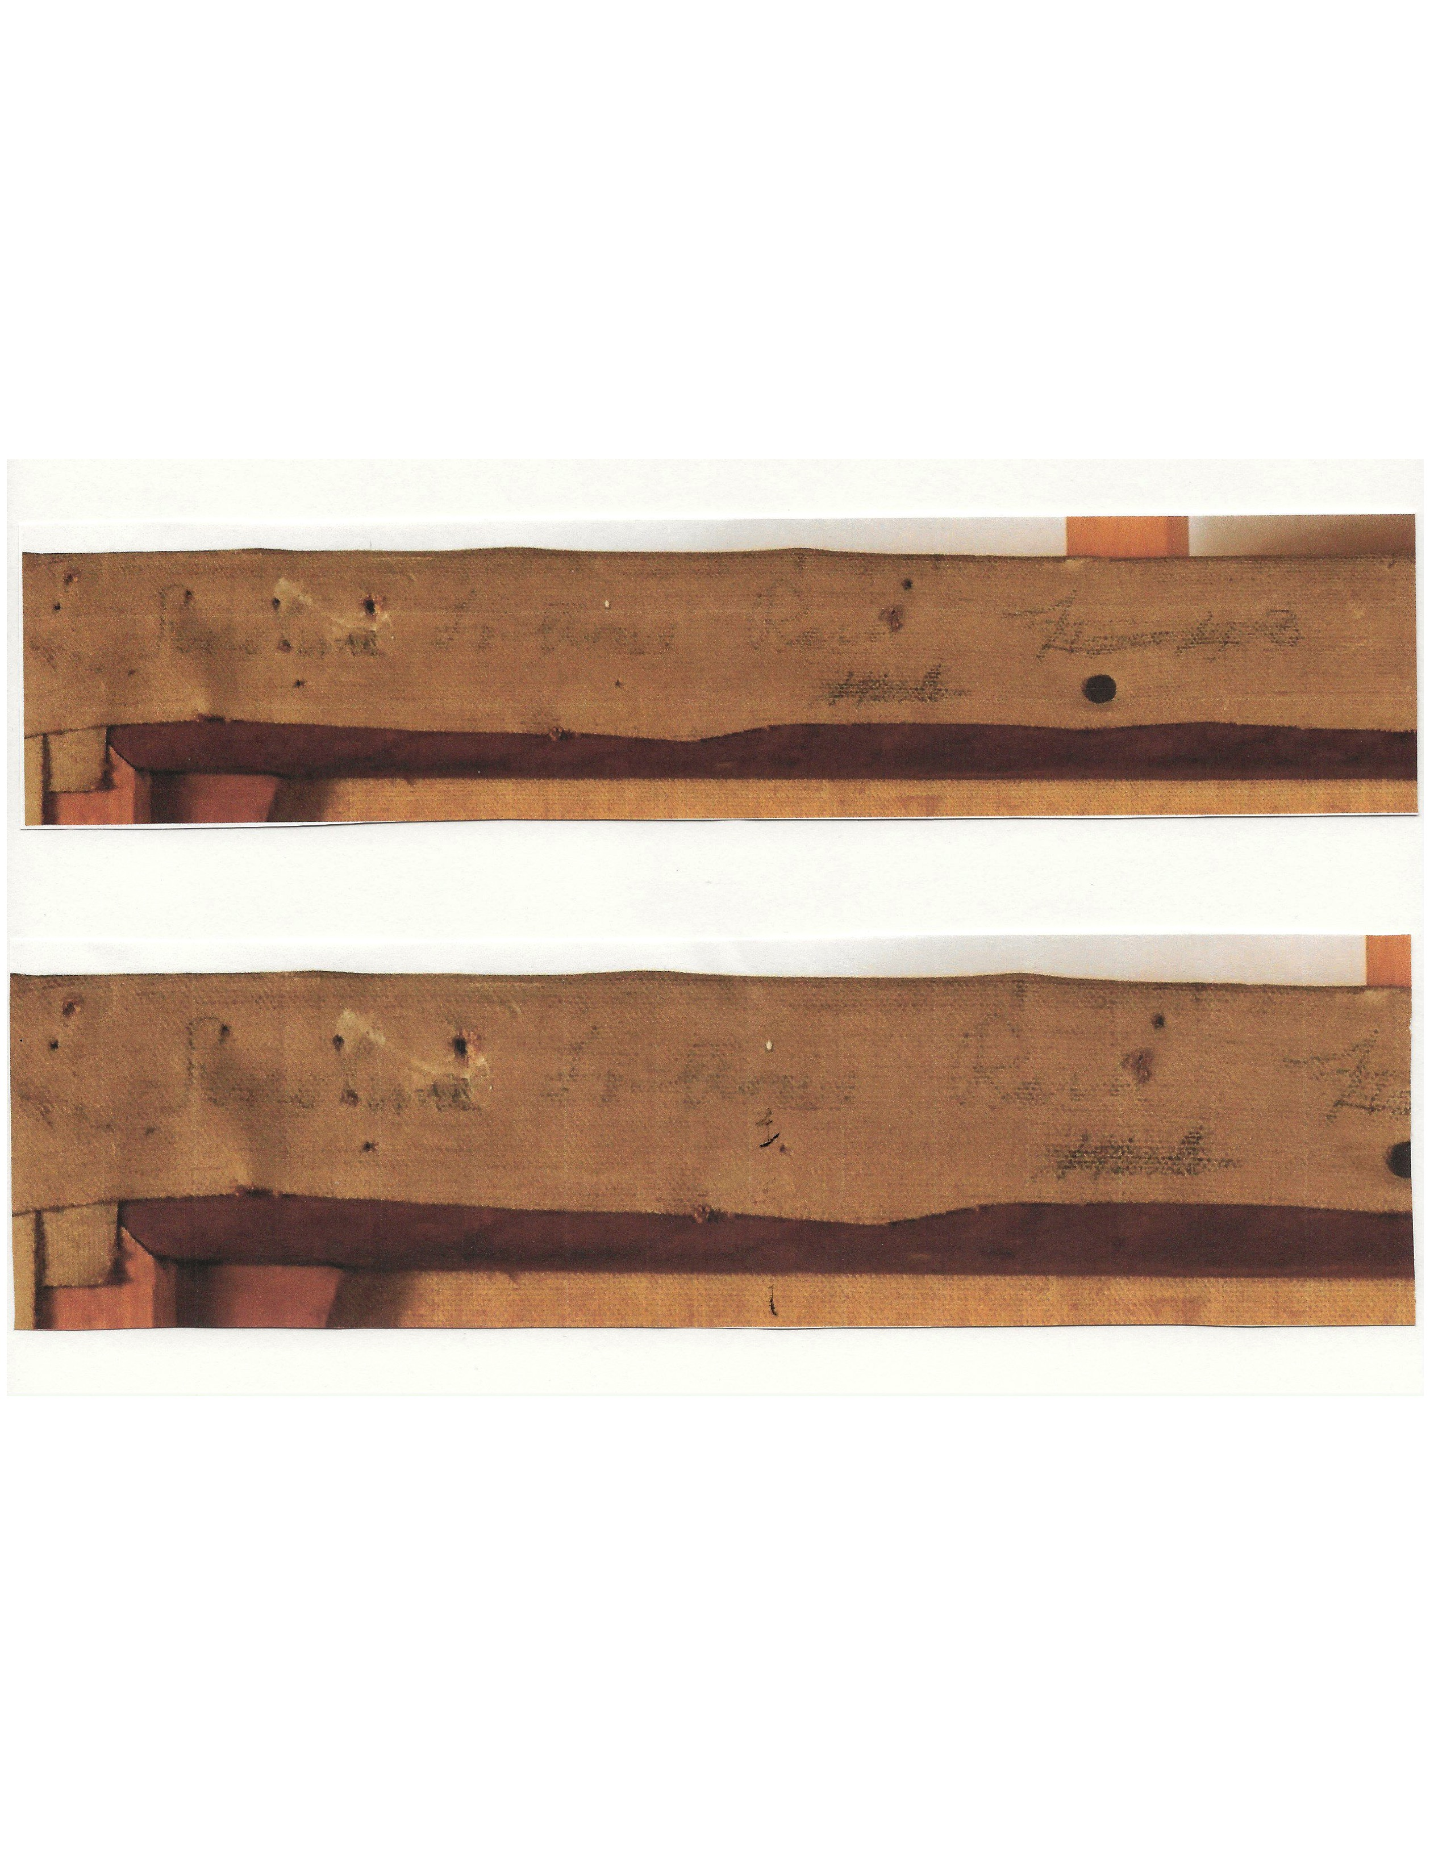

2. TITLE OF PAINTING.

The name of this painting is “SUNSHINE FOLLOWS RAIN”. 1. Also known by the name “AS THE RAIN PASSES”. 2, 3.

FOOTNOTES: TITLE OF PAINTING.

1. Stashka Star Art Conservation, Dallas, Texas performed conservation work on this painting in January 2018. A copy of the photographs taken, before and after the conservation, are attached to the back of the painting. The photograph of the back of the painting, before conservation, when magnified, in the upper left-hand corner of the canvas, in the area where the canvas is tacked down to the stretcher shows the name “SUNSHINE FOLLOWS RAIN”. A close up photocopy of this area, was sent to Sam Pemberton by email from Richard Star, husband and assistant to Stashka Star. Email from Stashka Star verifies that, based on her review of the original digital photographs, the writing on the painting says “SUNSHINE FOLLOWS RAIN”

2. This painting is also known under the name “AS THE RAIN PASSES”. This name was used for the painting in various exhibitions. It is not uncommon for alternate names or descriptive names to be used in exhibition. See “El Paso Herald”, El Paso, Texas, March 5, 1928. This article discusses the Dawson Dawson Watson exhibition in El Paso, Texas, in March of 1928, and states:

“Perhaps the best composition in the group is exhibit #29, called “As The Rain Passes”. It is representative of the country 20 miles from San Antonio, showing cactus and a sunlit field in the foreground with a passing shower in the background edged with a rainbow”.

3. The painting shows the entrance to The Gallagher Ranch. The entrance to The Gallagher Ranch was a common location that was often painted by Dawson Watson and is the subject of many of his cactus and bluebonnet paintings. He and his wife lived on the ranch at times and attended many social and other activities there. Richard Plumley, “Fine Arts Of Texas”, San Antonio, Texas, acquired two large Dawson Dawson Watson paintings from the ranch which he sold to Ace Cook, owner of “The Hock Shop Collection” of Early Texas Art. One of the paintings was “Flowers Of Silk” shown in The Davis Competition. The Gallagher Ranch was located approximately 20 miles from San Antonio.

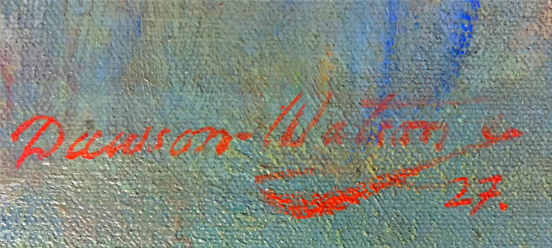

3. PROVENANCE.

1935 – Mrs C. M. Caldwell of the prominent Caldwell family in Abilene, Texas. (possible) 4.

Early 2000’s – The painting comes out of an Oklahoma Estate and is being shopped around to Texas Art dealers by the estate for $65,000. 5.

Early 2000’s – The painting is purchased from the Oklahoma Estate by a Texas/California businessman for $65,000. 6.

April 2014 – The painting is consigned by the Texas/California businessman to Early Texas Art dealer, Richard Plumley, “Fine Arts Of Texas”, San Antonio, Texas. 7.

April 2014 – Richard Plumley places the painting with “David Dike Fine Arts” for sale on consignment. 8.

April 2015 – January 2018 – The painting is being shown on consignment in the gallery of “Fine Arts Of Texas”, San Antonio, Texas.

January 2018 – The painting is purchased by King Ranch Chairman Of The Board and heir, James H. Clements Jr. 9.

January 2018 – The painting is sent to Stashka Star Art Conservation, Dallas Texas by James H. Clements Jr. for conservation at a cost of $5500. A new Motyka gold leaf frame is purchased for the painting at a cost of $1800. 10.

October 2019 – The painting is purchased by Early Texas Art collectors, Sam and Karen Pemberton, Austin, Texas from James H. Clements Jr. for $50,000. 11.

FOOTNOTES: PROVENANCE.

4. “The Portal To Texas History”: Digital images from a scrapbook “containing clippings and event information for the Art Unit of the “Abilene Women’s Forum Club” in Abilene, Texas for the years 1922 -1955”. This scrapbook documents “An Exhibition Of Paintings” by Dawson Dawson Watson, San Antonio, Texas at the “Wooten Hotel”, March 29-30, 1935. A copy of the catalog for the exhibition is contained in “The Portal To Texas History” and shows that nine paintings were in the exhibition. Exhibition item #9 is “As the Rain Passes”, loaned by Mrs. C. M. Caldwell. This provenance information is only “possible” since two different paintings may have been exhibited under the name “As The Rain Passes”. See “Exhibition Analysis”.

5. Emails from Richard Plumley, “Fine Arts of Texas”, San Antonio Texas document that in the early 2000’s an Oklahoma Estate was contacting various Early Texas Art dealers offering to sell the painting for $65,000.

6. The painting was purchased from the Oklahoma Estate by a Texas/California businessman. He owned the painting till April of 2014 when it was consigned for sale with “Fine Arts Of Texas”, San Antonio, Texas. According to Richard Plumley the individual was going to be out of the country for some number of years for business and he decided to sell the painting rather than store it. Email from Richard Plumley.

7. The painting was consigned by the Texas/California businessman to “Fine Arts Of Texas” with instructions to sell the painting . The seller wanted to net his original purchase price of $65,000. This would have required a gross sale price of approximately $80,000 after sales tax and commission. Email from Richard Plumley.

8. “Fine Arts of Texas” placed the painting with “David Dike Fine Art”. It was received in the “David Dike Gallery” in April of 2014. Interview with David Dike, May 2020. Tiara Jenkins, Gallery Manager, checked the “David Dike Gallery” records in May of 2020 for me and confirmed the above consignment date. Approximately April 2015, the painting was returned to “Fine Arts of Texas” where it remained on consignment in their gallery.

9, 10. In January 2018 the painting was sold by”Fine Arts Of Texas” to James H. Clement Jr. James H. Clement Jr is one of the King Ranch heirs and Chairman Of The Board of the King Ranch. Immediately after the sale the painting was sent from “Fine Arts Of Texas” to “Stashka Star Art Conservation” for conservation and for the application of a new frame. The cost of the conservation was $5500 and the frame $1800 according to Richard Plumley, owner “Fine Arts Of Texas”. Attached is a card to Sam and Karen Pemberton from James H. Clement Jr at the time they purchased the painting. Attached are emails between Sam Pemberton and the office of James H. Clement Jr to finalize the purchase.

11. In October, 2019, the painting was purchased by Early Texas Art collectors, Sam and Karen Pemberton, Austin Texas. Shortly after James H. Clement Jr purchased the painting in January 2018, he had the opportunity to purchase a large Onderdonk bluebonnet from the estate of his mother. He also had the opportunity to purchase a large, well known, Tom Lea painting. As a result he placed this painting back on the market to raise funds to offset these purchases. May 2020 email from Richard Plumley.

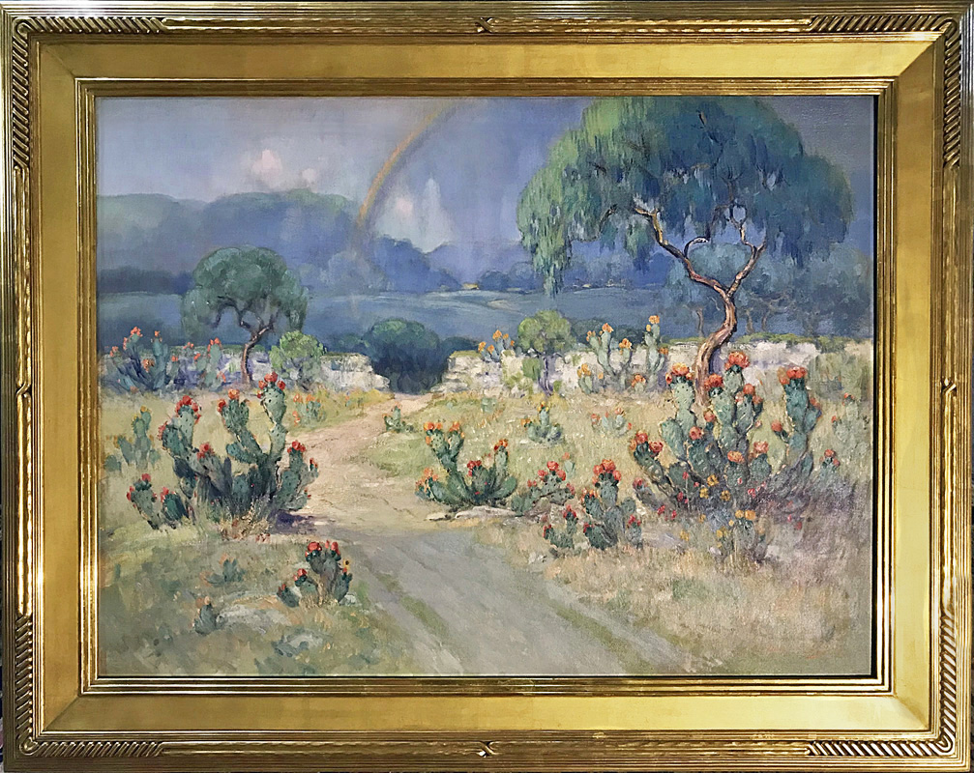

4. EXHBITIONS.

1927 – “Kansas City Art Institute”, Kansas City, Missouri. Solo Exhibition, November 1927. 12, 13, 14, 15, 16.

1928 – “Witte Memorial Museum”, San Antonio, Texas. Solo Exhibition, December 10, 1927 to January 8, 1928. 17, 18.

1928 – “Tucson Fine Arts Association”, Tucson, Arizona. Fine Arts Association Gallery in The Temple. Solo Exhibition, February 1, 1928 to February 19, 1928. 19, 20, 21, 22, 23, 24, 25, 26, 27.

1928 – “El Paso Art Guild”, Hotel Paso del Norte, El Paso, Texas. Solo Exhibition, March 3, 1928 to March 12, 1928. 28, 29, 30, 31, 32, 33, 34.

1929 – “Texas Cotton Palace Exposition”, Waco, Texas. 35, 36, 37.

1930 – “Texas Cotton Palace Exposition”. Waco, Texas. 35, 36, 37.

5. POSSIBLE ADDITIONAL EXHIBITIONS.

1927. – “Nashville Art Association”, Annual Southern Artists Exhibit. April 8, 1927 to April 25, 1927. 38, 39.

1928 – “Abilene Women’s Forum”, Abilene, Texas. 40, 41, 42, 43.

1935 – “Abilene Women’s Forum”, Abilene, Texas. Solo Exhibition. 44, 45.

FOOTNOTES: EXHIBITIONS and POSSIBLE ADDITIONAL EXHIBITIONS.

12. The Kansas City exhibition is documented in the “El Paso Herald”, El Paso, Texas, March 5, 1928: “Public reception in honor of Dawson Dawson Watson, San Antonio Artist, who received the highest honors at the recent art contest in that city, is being held by the El Paso Art Guild in its studio at Hotel Paso del Norte, where 50 of his paintings are on exhibition this week.” “All pictures of the exhibit were previously shown at Kansas City, San Antonio, and Tucson”……..”Perhaps the best composition in the group is exhibit No. 29, called “As The Rain Passes”. It is representative of the country 20 miles from San Antonio, showing cactus and a sunlit field in the foreground with a passing shower in the background edged with a rainbow”.

13. “St Louis Globe-Democrat”, St Louis, Missouri. September 11, 1927: “Now he (Dawson Watson) is going back to direct the 1928 contest (Davis Competition), and to open his art school in San Antonio. He came to St Louis, partly to make up his traveling exhibition, which Robert Holland, director of the Kansas City Art Institute, has invited for the month of November……….All frames were designed and actually made by the artist himself.”
According to my information from Richard Plumley, “Fine Arts Of Texas”, and this article, “Sunshine Follows Rain”/”As The Rain Passes” would have originally had a Dawson Watson hand carved frame, and would have probably had the various exhibition labels on the back. When the painting came out of the Oklahoma Estate in the early 2000’s, the frame was missing, replaced at some point before that time.

14. This Kansas City exhibition was held in November of 1927 before the “Witte Memorial Museum” exhibition that started December 10, 1927 and ended January 8, 1928.

15. “St Louis Globe-Democrat”, St Louis, Missouri, September 11, 1927: “……We want to tell St Louis something about the Temple Of Art in Tucson, Arizona, where these same pictures are to be shown after the middle of January. In the interim they will go to San Antonio for a tremendous one-man exhibition to include about twenty pictures that were bought last spring by discriminating San Antonians, which will be lent by their owners for the occasion. That will be the December event in the spacious galleries of the San Antonio Association for the Promotion of Art and Culture…..”.

16. “Kansas City Star”, Kansas City Missouri, November 7, 1927. “the November exhibition of the “Kansas City Art Institute” was hung today at 3500 Warwick Boulevard. The exhibition consists of oil paintings by Charles Partridge Adams and paintings, monotypes, water colors, and engravings by Dawson Dawson-Watson.”……..”Mr Dawson-Watson is a former resident of St Louis and now is living at San Antonio, Texas. He won the $5000 award in the recent Texas Wild Flower Competitive Exhibition. His prize winning canvas was a study of cactus in bloom. Several studies of this plant are in the collection of his work now at the institute.”

17. The exhibition at the “Witte Memorial Museum” in San Antonio is also documented in the same story noted in footnote 12. “El Paso Herald”, El Paso, Texas, March 5, 1928: “Public reception in honor of Dawson Dawson Watson, San Antonio Artist, who received the highest honors at the recent art contest in that city, is being held by the El Paso Art Guild in its studio at Hotel Paso del Norte, where 50 of his paintings are on exhibition this week.”……….“All pictures of the exhibit were previously shown at Kansas City, San Antonio, and Tucson”………..”Perhaps the best composition in the group is exhibit No. 29, called “As The Rain Passes”. It is representative of the country 20 miles from San Antonio, showing cactus and a sunlit field in the foreground with a passing shower in the background edged with a rainbow”

18. The “Witte Memorial Museum” exhibition, San Antonio, contained 50 paintings as noted in the article in the “El Paso Herald”, El Paso, Texas, March 5, 1928. It is apparent that this exhibition of 50 paintings was shown in Kansas City, San Antonio, Tucson, El Paso and Abilene and is the “traveling exhibition” referred to in footnote 13. See “Catalogue of Oil Paintings – Water Colors, Monotypes and Engravings by Dawson-Watson”, Witte Memorial Museum, Brackenridge Park, December 10th to January 8th.

19. The Tucson exhibition is also documented in the “El Paso Herald”, El Paso, Texas, March 5, 1928: “Public reception in honor of Dawson Dawson Watson, San Antonio Artist, who received the highest honors at the recent art contest in that city, is being held by the El Paso Art Guild in its studio at Hotel Paso del Norte, where 50 of his paintings are on exhibition this week.”………..“All pictures of the exhibit were previously shown at Kansas City, San Antonio, and Tucson”………...”Perhaps the best composition in the group is exhibit No. 29, called “As The Rain Passes”. It is representative of the country 20 miles from San Antonio, showing cactus and a sunlit field in the foreground with a passing shower in the background edged with a rainbow”

20. “Arizona Daily Star”, Tucson, Arizona, January 22, 1928: “The pictures of Dawson Dawson Watson have arrived in Tucson and will be hung the first of February”.

21. “Arizona Daily Star”, Tucson, Arizona, January 29, 1928: “An Englishman who has learned to love America’s deserts, an artist who prefers painting cacti to English green meadows and a man who had the backbone to get out of a country where his father is considered a great artist…….that is Dawson Dawson Watson. The paintings by this artist have arrived in Tucson and will be hung this week by the “Tucson Fine Arts Association”, the exhibit to open sometime soon after the first of February.”

22. “Arizona Daily Star”, Tucson, Arizona, February 2, 1928: “….it is expected that several of the Dawson Dawson Watson pictures in the February showing will be purchased. The exhibit opened yesterday with a large attendance”. The exhibit is being held in the “Temple Gallery”.

23. “Arizona Daily Star”, Tucson, Arizona, February 5, 1928: “The Dawson Dawson Watson exhibit by the “Tucson Fine Arts Association” will continue thru this week with a hostess in charge each afternoon…..”

24. “Arizona Daily Star”, Tucson, Arizona, February, 17, 1928: “The public is invited to view the Dawson Dawson Watson paintings at the “Tucson Fine Arts Association” gallery in the “Temple of Music” this afternoon between 2:30 and 5:30 o’clock”

25. “Arizona Daily Star”, Tucson, Arizona, February 19, 1928: “Mr. and Mrs. Dawson Dawson Watson will arrive in Tucson at the close of next week for a brief visit with friends. They will leave their San Antonio home February 20 and stop in El Paso for a short visit before coming on to Tucson. The exhibit of his paintings, which may be seen for the last time today at the Fine Arts Association gallery in The Temple will be taken down and sent to El Paso”

26. “Arizona Republic” Tucson, Arizona, February 26, 1928: “Mr. and Mrs. Dawson Dawson Watson arrived in Tucson a day or two ago for a brief visit with art friends. They left their San Antonio home February 20. The exhibit of his paintings was an event of the week at the Fine Arts Association gallery in The Temple. The pictures will go to El Paso”

27. The paintings are traveling from town to town. Kansas City, San Antonio, Tucson, and El Paso.

28. “El Paso Times”, El Paso, Texas. February 7, 1928: “Art Publicity and education work projected by the guild of artists here is already reaping tangible results in the attraction to El Paso of nationally known painters and exhibits. Notable among these is the showing of landscapes of Dawson Dawson Watson, winner of the $5000 prize at the exhibition of the San Antonio Art League, who has telegraphed acceptance to the guild’s invitation to being his paintings here during March.”

29. “El Paso Herald”, El Paso, Texas, March 5, 1928: This exhibition is documented as follows: “Public reception in honor of Dawson Dawson Watson, San Antonio Artist, who received the highest honors at the recent art contest in that city, is being held by the El Paso Art Guild in its studio at Hotel Paso del Norte, where 50 of his paintings are on exhibition this week.”…………“All pictures of the exhibit were previously shown at Kansas City, San Antonio, and Tucson”…….…..”Perhaps the best composition in the group is exhibit No. 29, called “As The Rain Passes”. It is representative of the country 20 miles from San Antonio, showing cactus and a sunlit field in the foreground with a passing shower in the background edged with a rainbow”

30. “El Paso Evening Post”, El Paso, Texas, February 28, 1928: “ El Pasoan’s will have the opportunity of seeing 50 of Dawson Dawson Watson’s oil paintings at the exhibit to open here March 3, in the rooms of the El Paso Art Guild, Hotel Paso del Norte.”………….“Dawson Watson’s paintings are valued ranging from $150 to $1500”. “Sunshine Follows Rain”/”As The Rain Passes” has a notation of the price, $1500. on the bottom edge of the canvas. This can be clearly seen in the “before” digital photographs taken by Stashka Star at the start of her conservation work on the painting in January 2018.

31. “El Paso Evening Post”, El Paso, Texas. March 3, 1928: “Dawson Dawson Watson, San Antonio painter, who opened an exhibition of his paintings in the El Paso Art Guild Studio, third floor of Hotel Paso del Norte, today said he never saw a business man until he was 21 years old………His paintings will be on exhibit until March 12”

32. “El Paso Evening Post” March 6, 1928: “Mrs. Dawson Watson said she had “a finger in the pie” in “The Rainbow”, a favorite in the exhibition and a prize winner in the Nashville 1928 (1927 actually) exhibition. It is a picture of a rainbow ending in a bed of blue bonnets. The rainbow was changed to her liking”. This article references the collection of 50 paintings being shown.

33. “Early El Paso Artists”, “El Paso Centennial Museum”, Carol Ann Price, Texas Western Press, The University Of Texas At El Paso, 1983, Page 20. In the late 1920’s (the organizational meeting was in 1927) El Paso artists formed their first major organization, the “Arts And Crafts Guild”. They found club and display-room space on the third floor of the Paso del Norte Hotel, thanks to Paul Harvey, the owner. It was a beautiful spot for exhibits, built over the roof of the old Unique Theatre, with an outdoor walkway, well placed windows, and sky lights. Harvey kept pictures by local artists on permanent display on the hotel mezzanine and the Guild held many exhibits in the third floor studio for local and visiting artists.

34. “Early El Paso Artists”, “El Paso Centennial Museum”, Carol Ann Price, Texas Western Press, The University Of Texas At El Paso, 1983, Pages 21. The Art Guild in the Paso del Norte was the scene of many art exhibits. This hotel became a place for artists to exhibit regularly. Many paintings were hung in the third floor studio and all around the hotel, so that visitors to El Paso could see the local artists work.

35. “Texas Artists and Artisans 1718-1959, Vol I: A-G”. Vic Roper. First Edition 2017, Page 242: “Exhibitions”…..”Waco Cotton Palace, 1929, 1930, “Sunshine Follows Rain”.

36. Baylor University Library System. “Texas Cotton Palace Records, Inclusive: 1894-1931”, “Literary Productions 1911-1930, undated”, Box 1, Folder 19: “Art Catalogs 1924-1930”.

37. 1930 “Art Catalog”, “Texas Cotton Palace Exposition and Dairy Show”. From Baylor University Library System, see footnote 32: Under “Texas Artists” item number 66, “Sunshine Follows Rain”, “Dawson Dawson Watson”, “Pabst Galleries”. The catalog shows that the Pabst Galleries, San Antonio, had 12 paintings in the exposition out of the 19 total paintings for the category “Texas Artists”. Other artists represented by Pabst Galleries in the show are Adrian Brewer, Paul Schuman, Anthony DeYoung, Paul Rodda Cook, Rolla Taylor, and John Enser.

38. “The Tennessean”, Nashville, Tennessee, April 8, 1927. “Following a plan inaugurated by the president, Mrs. James C. Bradford, the Nashville Art Association is now holding the annual exhibit of the works of Southern Artists in the gallery of Carnegie Library, the states being represented at this time being Mississippi, an Texas, with an additional exhibit from Southern California.”…….”Notable examples among the Texas group now on display are the following numbers: 53. Showing a rainbow hovering over a field of harebells, by Dawson Watson Of San Antonio”.

39. “The Tennessean”, Nashville, Tennessee, April 25, 1927. “Prizes and honorable mention given by the “Nashville Art Association” to paitings exhibited by Texas and Mississippi artists during the recent weeks at the Carnegie Library were announced by Mrs. J. C. Bradford president of the association Saturday”…..”Special Oil Class, “The Rainbow”, Dawson Wtson, first prize.”

40. “As The Rain Passes” is exhibited in Abilene, Texas. “Texas Artists and Artisans 1718-1959, Vol 1: A-G”, Vic Roper. First Edition 2017, page 242: “Exhibitions”…..”Abilene Women’s Forum”, 1928, “As The Rain Passes”.

41. “Texas Artists and Artisans 1718-1959, Vol I: A-G”. Vic Roper. First Edition 2017, page 242: “Exhibitions”……”Abilene Women’s Forum”, 1928, “As The Rain Passes”.

42. “Abilene Woman’s Forum”, “Art Forum Scrapbook, 1922-1933”, page 67 of 365, Catalog, “Sixth Annual Exhibition of Paintings By Texas Artists”, Abilene, Texas, May 11 through 14th. This catalog documents the exhibition of Texas artists at the Abilene City Hall May 11 through may 14th, 1928. The listing for Dawson Dawson Watson states “Watson, Dawson, 1118 St Mary’s St San Antonio, Texas, #59 “As The Rain Passes”.

43. “Abilene Reporter-News”, Abilene, Texas, May 13, 1928. Article titled “Sixty Five Paintings By Texas Artists Comprise Exhibit In City Hall Auditorium”. “Blue Bonnets Are In Favor”. “No bluebonnet landscape received more favorable comment from visitors Saturday than that by Dawson Dawson Watson landscape painter of San Antonio. “As The Rain Passes”. The show is richer for the good painting and harmonious color affects of this canvas which has in the foreground, a massing of bluebonnets directly back of this the green of the mountains, and breaking in the background a rainbow in light shadings”.

44. “The Portal To Texas History”, Hardin-Simons University Library. Abilene Women’s Art Forum Scrapbook, 1922-1955: From the scrapbook, the following exhibition catalog: “An Exhibition of Paintings by Dawson Dawson Watson, San Antonio. Wooten Hotel, Abilene, Texas, March 29-30, 1935”. Item number 9, “As The Rain Passes”, loaned by Mrs. C. M. Caldwell”.

45. “Abilene Reporter-News”, Abilene, Texas, March 31, 1935: “Hardin-Simmons Art Group Sponsors Public Exhibition of Dawson Dawson Watson’s Work at Tea for Which 250 Guests Are In Attendance”…………”Spring activities kept members of the Hardin-Simmons University Art League busy this weekend. Interest centering on a banquet and theatre party Saturday night , public exhibition of Dawson Dawson Watson’s work that day and the annual tea for the Round Table, wives of University trustees and the Art Unit of the Woman’s Forum, Friday.”…….”Approximately 250 guests called Friday afternoon on the Wooten Mezzanine, between the hours of 3 and 5 o’clock when nine paintings by Dawson Watson were displayed”.

6. GALLERIES.

1929/1930 – “Sunshine Follows Rain”/”As The Rain Passes” is represented by Pabst Galleries, San Antonio, Texas. See footnotes 33, 34, 35.

2014 – David Dike Fine Art, Dallas, Texas. On consignment. See footnote 8.

2015-2018 – Fine Arts Of Texas Gallery, San Antonio, Texas. On consignment. See footnotes 7, 8, 9.

7. BOOKS/PUBLICATIONS/ NEWSPAPER ARTICLES/ SOURCES.

Abilene Reporter-News, May 13, 1928, Abilene, Texas.
“Abilene Women’s Forum Scrapbook”, 1922-1923, Portal To Texas History.

“Abilene Public Library”, Abilene, Texas.

“Arizona Historical Society”, Tucson, Arizona.

Baylor University, “Texas Cotton Palace Records, Inclusive: 1894-1931”, Box 1, Folder 19, Art Catalogs. See footnote 34, 35.

Baylor University Library System, Waco, Texas.

Rachael Black, Archivist/Librarian, “Arizona Historical Society”, Tucson, Arizona.

David Dike, “David dike Fine Art”, Dallas, Texas.

Dawson Dawson Watson Catalog Raisonne Project.

Elizabeth Davis, Visual Archival Resources Specialist, Jannes Library, “Kansas City Art Institute”, Kansas City, Missouri.

Michael Grauer, “National Cowboy And Western Heritage Museum”, Oklahoma City, Oklahoma.

El Paso Public Library, El Paso, Texas.

“El Paso Museum Of Art”, El Paso, Texas.

Amy Fulkerson, Chief Curator, “Witte Museum”, San Antonio, Texas.

El Paso Art Association, El Paso, Texas.

“Early El Paso Artists”, Carol Ann Price, “El Paso Centenial Museum”, Texas Western press, University Of Texas at El Paso, 1983.

Hotel Paso del Norte, El Paso, Texas, El Paso, Texas.

Tiara Jenkins, Gallery Manager, “David Dike Fine Art”, Dallas, Texas.

“Kansas City Star”, November 7, 1927, Kansas City, Missouri.

“Kansas City Art Institute”, Jannes Library, Kansas City, Missouri.

Joseph Longo, “El Paso Historical Society”, El Paso, Texas.

Carol Price Miller, El Paso, Texas.

Newspapers.com, “St Louis Globe-Democrat”, St Louis, Missouri, September 11, 1927. See footnotes 13, 14, 15.

Newspapers.com, “Arizona Daily Star”, Tucson, Arizona. January 22, and 29, 1928, February 2,5, 17, 19, and 26, 1928. See footnotes 19, 20, 21, 22, 23, 24.

Newspapers.com, “Arizona Republic” Tucson, Arizona, February 26, 1928. See footnote 25.

Newspapers.com, “El Paso Times”, El Paso, Texas. February 7, and 28, 1928, March 3, 5, 6, and 8, 1928. See footnote 27.

Newspapers.com, “El Paso Herald”, El Paso, Texas, March 5, 1928. See footnote 28.

Newspapers.com, “El Paso Evening post”, El Paso, Texas. February 28, 1928, March 3, 1928, March 28, 1928. See footnotes 29, 30, 31.

Newspapers.com, “Abilene Reporter-News”, Abilene, Texas. March 31, 1935. Footnote 37.

Newspapers.com, “St Louis Globe-Democrat”, St Louis, Missouri, September 11, 1927. See footnotes 13, 14, 15.

“The Portal To Texas History”, Hardin-Simons University Library, Abilene Women’s Art Forum Scrapbook, 1922 – 1955, Abilene, Texas. See footnote 4, 36.

Amie Olivar, Interim Director and Librarian/Curator Of print Materials, “The Texas Collection”, Baylor University, Waco, Texas.

Richard Plumley, “Fine Arts Of Texas”, San Antonio Texas.

“Portal To Texas history”, texashistory.unt.edu.

Claudia Ramirez, Library Archivist, El Paso Public Library, El Paso, Texas.

Bernadette Ramos, Art Handler/Gallery Technician, “El Paso Museum Of Art”, El Paso, Texas.

Tony Redman, Librarian/Adult Services, Abilene Public Library, Abilene, Texas.

Claudia Rivers, Director, “Centenial Museum”, Special Collections Department, University Of Texas El Paso, El Paso, Texas.

Stashka Star, “Stashka Star Art Conservation”, Dallas, Texas.

Richard Star, “Stashka Star Art Conservation”, Dallas, Texas.

“Stark Museum Of Art”, Orange, Texas.

“Texas Artists And Artisans 1718 – 1959, Vol. I: A-G, by Vic Toper, 2017. See footnotes 32, 33.

Benna Vaughan, Manuscripts Archivist, Baylor University Library System, Waco, Texas.

“Witte Museum”, San Antonio, Texas.

8. OTHER INFORMATION.

On verso, bottom edge of canvas, $1500. See footnote 29.

9. PROVEN EXHIBITIONS - ANALYSIS.

In compiling the above information, I tried to use “PROBABILITY” as my standard. I will now discuss my findings and will state my conclusions based on my research. I will use “probability” as the standard for this discussion.

FIRST: What information has been established to a “CONCLUSIVE PROBABILITY”? The various sources and materials establish to a “conclusive probability” that the subject painting “Sunshine Follows Rain”/”As The Rain Passes” was, at a minimum, exhibited at the following exhibitions:

1928 – “El Paso Art Guild”, Hotel Paso del Norte, El Paso, Texas. Solo Exhibition, March 3, 1928 to March 12, 1928.

1929 – “Texas Cotton Palace Exposition”, Waco, Texas.

1930 – “Texas Cotton Palace Exposition”, Waco, Texas.

The description of the painting in the El Paso exhibition as set out in the March 5, 1928 “El Paso Herald” article is an exact description of the subject painting. The “Texas Cotton Palace Exhibition” catalog and the Vic Roper book clearly and conclusively show that “Sunshine Follows Rain”/”As The Rain Passes” was exhibited at the Cotton Palace in 1929 and 1930.

SECOND: What exhibitions have been established to a “HIGH PROBABILITY”? The various sources and materials establish to a “high probability” that the subject painting “Sunshine Follows Rain”/”As The Rain Passes” was exhibited at the following additional exhibitions:

1927 – “Kansas City Art Institute”, Kansas City, Missouri. Solo Exhibition, November 1927.

1928 – “Witte Memorial Museum”, San Antonio, Texas. Solo Exhibition, December 10, 1927 to January 8, 1928.

1928 – “Tucson Fine Arts Association”, Tucson, Arizona. Fine Arts Association Gallery in The Temple. Solo Exhibition, February 1, 1928 to February 19, 1928.

Numerous news articles, footnoted in this paper, establish that the same exhibition of 50 paintings was traveling from Kansas City, to San Antonio, to Tucson, to El Paso. We also know, from the El Paso leg of this traveling exhibition and the March 5, 1928 “El Paso Herald” article, that Exhibit Item #29 in El Paso, called “As The Rain Passes”, is an exact, descriptive, match for the subject painting. The same article notes that the same paintings being shown in El Paso were shown in the various prior cities (Kansas City, San Antonio, and Tucson).

THIRD: If we combine the “CONCLUSIVE PROBABILITY” exhibitions and the “HIGH PROBABILITY” exhibitions under the name “Sunshine Follows Rain”/”As The Rain Passes”, the list of exhibitions is as follows:

1927 – “Kansas City Art Institute”, Kansas City, Missouri. Solo Exhibition, November 1927.

1928 – “Witte Memorial Museum”, San Antonio, Texas. Solo Exhibition, December 10, 1927 to January 8, 1928.

1928 – “Tucson Fine Arts Association”, Tucson, Arizona. Fine Arts Association Gallery in The Temple. Solo Exhibition, February 1, 1928 to February 19, 1928.

1928. – “El Paso Art Guild”, Hotel Paso del Norte, El Paso, Texas. Solo Exhibition, March 3, 1928 to March 12, 1928.

1929 – “Texas Cotton Palace Exposition”, Waco, Texas.

1930 – “Texas Cotton Palace Exposition”, Waco, Texas.

10. POSSIBLE ADDITIONAL EXHIBITIONS - ANALYSIS

There are three additional exhibitions that are “POSSIBLE” exhibitions for the subject painting.

The first two possible additional exhibitions are the 1928 and 1935 “Women’s Art Forum” exhibitions in Abilene, Texas. Materials from both these exhibitions show that a painting called “As The Rain Passes” was exhibited at each.

What makes these two exhibitions tenuous is the fact that two different newspaper articles seem to describe two different paintings under the name, “As The Rain Passes”. In El Paso, the March 5, 1928 article in the “El Paso Herald” describes “As the Rain Passes” as follows:

“Perhaps the best composition in the group is exhibit #29, called “As The Rain Passes”. It is representative of the country 20 miles from San Antonio, showing cactus and a sunlit field in the foreground with a passing shower in the background edged with a rainbow”.

On May 13, 1928, just two months later the “Abilene Reporter-News” describes “As The Rain Passes” as follows:

“As The Rain Passes”. ……this canvas which has in the foreground, a massing of bluebonnets directly back of this the green of the mountains, and breaking in the background a rainbow in light shadings”.

So, there are two possible alternatives.

The two writers were describing the same painting, but the second writer, two months later, left out the cactus in his description and focused on the middle portion of the painting with the bluebonnets and rainbow. If this is the case, it is “possible” that the subject painting is the painting that is in both Abilene exhibitions.

Or, there are in fact two 1927 rainbow paintings with one being a cactus painting and the other being a bluebonnet painting.

If there are in fact, two different 1927 rainbow paintings under the name “As The Rain Passes”, we know that it was the second painting, (not the subject painting), that was in the 1928 Abilene exhibition.

We have no description of the painting in the 1935 Abilene exhibition. So, we don’t know which painting was in that exhibition.

I have not come across any information to clear up this issue. With these news articles being written ninety three years ago and no further information, there is no way to know what is “probable” for these two exhibitions. So we are left with “possibilities” and nothing we can say is “probable”.

There is a third, “possible additional exhibition” that can not be proven to a “PROBABILITY”. It is the 1927 “Nashville Art Association” Annual southern Artists Exhibit in Nashville in April of 1927.

This is the painting called “The Rainbow”.

Numerous references mention a Dawson Watson painting called “The Rainbow”. Roper in his book “Texas Artists and Artisans” mentions ‘The Rainbow” being exhibited in Nashville, Tennessee at the “Nashville Museum of Art” in 1927 and being a prize winner in the exhibition. “The Tennessean”, Nashville, Tennessee, April 8, 1927 documents an exhibition of Texas Artists:

“……the Nashville Art Association is now holding the annual exhibit of the work of Southern Artists in the gallery of the Carnegie Library, the states being represented at this time being Mississippi and Texas”………“Notable examples among the Texas group now on display are the following numbers: 52. Showing a rainbow hovering over a field of harebells by Dawson Watson of San Antonio”

A later news article in “The Tennessean” Nashville, Tennessee, April 25, 1927 discussing the exhibition states that prize winners of the recent exhibition of Mississippi and Texas paintings at the Carnegie Library were announced:

“Special Oil Class, “The Rainbow”, Dawson Watson, first prize.”:

An article from an El Paso, Texas newspaper, the “El Paso Evening Post”, March 6, 1928 discussing the impact of Mrs. Dawson Watson on her husbands’ career states:

“Mrs. Dawson Watson said she had “a finger in the pie” in “The Rainbow”, a favorite in the exhibition and a prize-winner in the Nashville 1928 (1927) exhibition. It is a picture of a rainbow ending in a bed of bluebonnets. The rainbow was changed to her liking”

In the article above, Mrs. Dawson Watson is attending the El Paso leg of the “traveling exhibition” that went from Kansas City, to San Antonio, to Tucson, to El Paso.

I do believe it is “PROBABLE” that one of the two paintings, “Sunshine Follows Rain”/”As The Rain Passes” (El Paso description) or the second “As The Rain passes” (Abilene description), is the painting called “The Rainbow”.

Once again it is a mystery that has no clear-cut answer.

There are again, two alternatives. If the two writers were describing the same painting, and the second writer (Abilene description), two months later, for some reason, left out the cactus (El Paso description) in his description and focused on the middle portion of the painting with the bluebonnets and rainbow, it is possible that the subject painting is “The Rainbow”.

If there are in fact two different 1927 rainbow paintings under the name “As The Rain Passes” (El Paso description and Abilene description) it is “possible” that the painting described in the Abilene Reporter-News is “The Rainbow”.

I can make arguments either way from the confusing and conflicted information that I found.

Here is the argument for “Sunshine Follows Rain”/ “As The Rain Passes” (El Paso description) “POSSIBLY” being “The Rainbow”.

Both descriptions of “The Rainbow” describe it as a rainbow ending in or hovering over a field of bluebonnets. “Sunshine Follows Rain”/ “As The Rain Passes” shows a rainbow hovering over a blue field with the end of the rainbow fading down into the blue. It meets the description of “The Rainbow” in the news article reporting on the 1927 Nashville show and also the description in the news article quoting Mrs. Dawson Watson in the 1928 El Paso show.

The 1927/1928 Witte Museum exhibition catalog lists a painting, “The Rainbow” as item number 29. In the El Paso leg of the same traveling exhibition, a few months later, item number 29 is described in the March 5, 1928 “El Paso Herald” newspaper article as follows:

“Perhaps the best composition in the group is exhibit #29, called “As The Rain Passes”. It is representative of the country 20 miles from San Antonio, showing cactus and a sunlit field in the foreground with a passing shower in the background edged with a rainbow”.

It is apparent from the description of the painting in the “El Paso Herald” article, that the subject painting is item 29 in El Paso. In San Antonio a few months earlier number 29 was called “The Rainbow”. Is it likely that item 29 in two different legs of the traveling exhibition would be two different “rainbow” paintings? I believe it is “possible” that item 29 is the same painting being referred to under two different names.

Is it likely that the traveling exhibition would use the same catalog numbers for the paintings in each city? I believe it is very likely that they would use the same catalog numbers for the paintings the entire tour. This would facilitate ease of printing exhibition catalogs as the traveling exhibition moved from city to city. If a painting was number 29 in one city, I believe it was likely still number 29 in the next city

A March 6, 1928 article in the “El Paso Evening Post” discussing Mrs. Dawson Watson’s role in “The Rainbow” describes “The Rainbow” as “a favorite in the exhibition”. A day earlier, on March 5, 1928 the news reporter for the “El Paso Herald” covering the same exhibition and presumably interviewing the artist or the same people calls “Sunshine Follows Rain”/“As The Rain Passes” the “best composition in the group.”

So we know that “the Rainbow” is cataloged as item number 29 and ”Sunshine Follows Rain”/”As The Rain Passes” is also cataloged as item number 29 at different times in the same traveling exhibition. We know that “The Rainbow” and ”Sunshine Follows Rain”/”As The Rain Passes” both have rainbow subject matter. We know that “The Rainbow” and ”Sunshine Follows Rain”/”As The Rain Passes” both depict a rainbow ending in a field of bluebonnets. We know that the number of paintings done by Dawson Watson with rainbow subject matter would be extremely limited. We know that both “The Rainbow” and ”Sunshine Follows Rain”/”As The Rain Passes” are described as the “favorite” painting and the “best” painting by two different news reporters in two different El Paso news articles published one day apart and dealing with the same show.

Here is the argument that it is the second (Abilene description) “As The Rain Passes”, that is “POSSIBLY” the painting called “The Rainbow”.

The description of the rainbow painting in Abilene is an excellent match for the descriptions of the paintings called “The Rainbow” in the Nashville newspaper article and in the El Paso article where Mrs. Dawson Watson is being interviewed. None of the three descriptions mention any cactus in the painting. All of the articles mention the painting as being bluebonnets with a rainbow.

In addition, the painting called “The Rainbow” by Mrs. Dawson Watson in El Paso is described as “a favorite in the exhibition”. The bluebonnet rainbow painting in the Abilene article is described by the writer as the bluebonnet landscape receiving the most favorable comment from visitor’s.

So we know that “The Rainbow” and As The Rain Passes” (Abilene description) both have bluebonnet and rainbow subject matter. We know that “The Rainbow” and ”As The Rain Passes” (Abilene description) both depict a rainbow ending in a field of bluebonnets. We know that the number of paintings done by Dawson Watson with rainbow subject matter would be extremely limited. We know that both “The Rainbow” and ”As The Rain Passes” are described as the “favorite” painting and the painting “receiving the most favorable comments” in two different news articles, El Paso and Abilene only two months apart.

I do believe that it is “PROBABLE”, if there are two “As The Rain Passes” paintings, that one of them is the painting called “The Rainbow”. Because of the multiple names and possible mixing of names from exhibition to exhibition it is not possible to clarify this issue.

11. CONCLUSION.

There is a “HIGH PROBABILITY” that the subject painting is a significant, extensively exhibited, Dawson Watson painting. It is telling that the artist, Dawson Watson, choose to exhibit the subject painting extensively. In my view, it shows that this is a painting that he thought was good work and that he liked. It is conclusively known that Dawson Watson priced the subject painting at his highest price level. The totality of the materials and reasonable conclusions that can be drawn from the materials show that Dawson Watson considered the subject painting to be an exceptional example of his work.

I have now exhausted all materials that bear on the history of the subject painting. I consider it an absolute miracle that I have been able to locate this large volume of materials and information for a ninety three year old painting that, when I started, the name and everything else about the painting was unknown.

My primary concern in compiling this material is to try to insure that this information is saved for future owners of this painting and preserved for future Dawson Dawson Watson researchers and collectors. Accordingly, I will provide copies of this paper to the various Early Texas Art auction houses as well as “CASETA” and other individuals and entities. This paper and copies of the most important supporting information will also be secured to the back of the subject painting.

Dated this 25th day of August, 2020.

Sam Pemberton
pembertonsam@hotmail.com
shpkep@gmail.com
281-704-9475
All pages, copyright 2020:Sam Pemberton

