“HILL COUNTRY SUMMER”
PORFIRIO SALINAS
COMPILED BY SAM PEMBERTON
SEPTEMBER – OCTOBER 2020

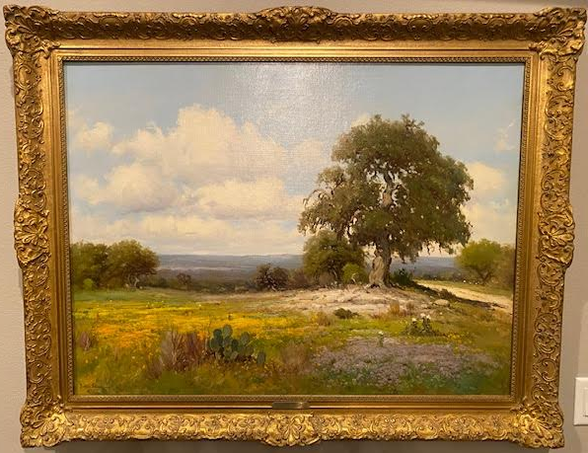

We purchased this large Salinas oil on canvas painting on August 25, 2014, from “Roughton Galleries” in Dallas, Texas. This is an exceptional, 30 x 40, early, Porfirio Salinas painting. Early Salinas paintings of this size and quality are highly sought after. What makes this painting special is the fact that it has extremely nice, thick paint, and is from a very desirable time in the artist’s career.

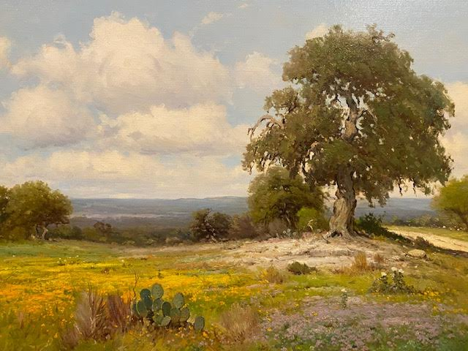

SEARCH FOR PROVENANCE.

Over the years since we purchased this painting, I have been able to piece together the history of “Hill Country Summer” back to the artist, Porfirio Salinas.

When we purchased this painting from “Roughton Galleries” in Dallas Texas, it was on consignment. According to the owner, Brian Roughton, the painting was consigned to their gallery by a Houston Oncologist in 2014. Mr Roughton also mentioned to us that he believed the painting had been sold to his client by David Dike.

So, within a few days, I sent out an email and called Anne Kelly at “David Dike Fine Art” and asked her if she know anything about the history of this painting. She provided the first new information on the provenance of this painting.

In an August 29, 2014 email Anne told me that the painting was sold by the “Jackson Walker Law Firm” to “David Dike Fine Art” in about 2004 -2005. The painting was than sold by David Dike to a Houston Oncologist.

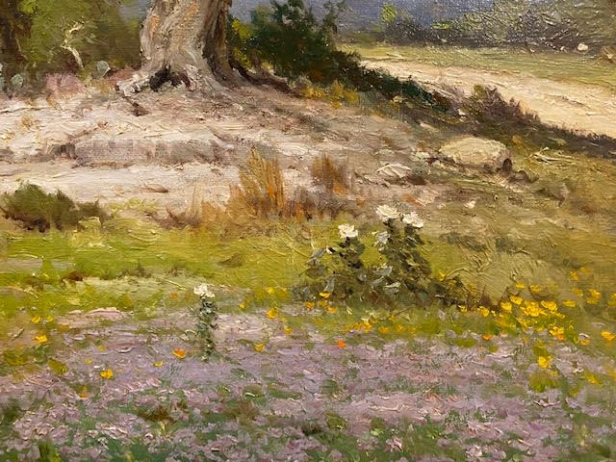

I did not pursue the issue further until January of 2015 when I decided to start researching again and learned that the ”Jackson Walker Law Firm” was still operating in Dallas. So, I sent off a series of emails to various employees whose names I got from the firms website.

My main contact at the “Jackson Walker Law Firm” became a staff member, Sharon Kasachkoff. She told me by email dated January 14, 2015:

“Sam, I have been told by one of our attorneys that painting came to JW through A.W. Walker who was an attorney at our firm. It was hung in our offices at our old building at 1401 Elm, Dallas Texas, than moved with us in 1985 to 901 Main St, Dallas Texas.”

I learned that Mr Walker was now deceased but there was a good volume of material about him online.

Mr A.W. Walker was an attorney and a very prominent Oil & Gas Law expert. He was a well known professor at the University of Texas Law School.

He was born in Denison, Texas in 1901 and died in 1987. Walker received a Baccalaureate Degree in 1921 and his Law Degree in 1923 from the University of Texas. He also did post graduate work at both Columbia and Yale in law. He practiced law for a couple of years and than became a Professor of Law at the University of Texas. He was a member of Phi Beta Kappa, the Order of the Coif, and was the editor of a case book on Oil & Gas Law.

During his time as a professor he became, arguably, the foremost expert on Oil & Gas Law in Texas. Walker was at the University of Texas for twenty five years. In 1948 he resigned from the faculty to re-enter the practice of law with the Dallas-based “Jackson Walker Law Firm”.

My research was revived once again in October of 2017. I decided to have Charles Morin, of “Vintage Texas Paintings” gallery in San Antonio, Texas, give me his opinion of the date that the painting was created. I believe that Mr Morin has handled more Salinas paintings than any other art dealer in Texas and is therefore an expert on Porfirio Salinas. He informed me by email on October 27, 2017 that the painting was:

“Most likely painted some time between 1938 and 1943”

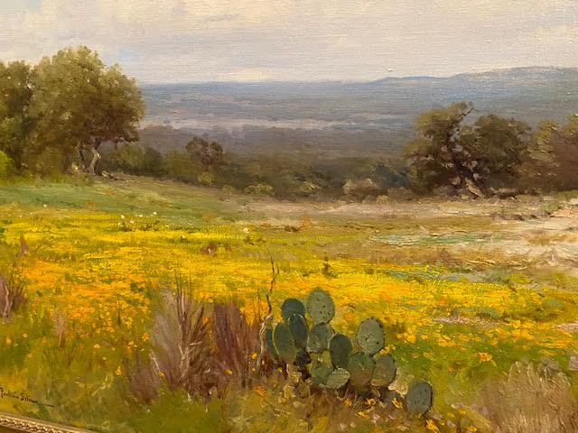

I acquired the next piece of the puzzle, by random chance, about a year later when I came across another source of information at the “Jackson Walker Law firm”. In August of 2018 I was reviewing some old email correspondence with an attorney named Jeff Sone. The emails were from March of 2004. Jeff and I had been biding against each other for a nice Dwight Holmes painting on eBay that month. After the auction was over we had some communication back and forth by email.

As I was going through those old emails between Jeff and myself, I noticed that his email account showed the name “Jackson Walker Law Firm” in Dallas. That name seemed familiar to me so I got out the information on the Salinas painting and confirmed that he was in the same law firm that was connected to “Hill Country Summer”. So, I contacted Jeff to see if he knew anything about the painting.

I now know that Jeff Sone, in addition to being an attorney is a prominent collector of Early Texas Art. On August 18, 2018 he told me by email:

“I remember that painting well, and wish I owned it. I didn’t arrive at JW until 1999. So, I never met A. W. Walker. But, what I heard generally is that he brought the painting from Salinas while he was a professor at UT Law. AW Walker joined our firm in 1948 and left Austin. Those dates (1938 – 1943, see Charles Morin quote above) make sense to me. Your painting is obviously an early work, and thus higher quality than later works.”

The dates in parenthesis in the above quote are the likely range of dates for the creation of the painting given to me by Charles Morin. I had communicated those dates to Jeff Sone in my initial inquiry to him. Jeff continued in his August 18, 2018 email to me:

“JW’s offices had a small number of Texas paintings and a larger Western theme décor. We even had a conference room decorated with antique rifles. Fun stuff. Over about five years leading up to our move of the Dallas office to minimalist space in the Arts District we sold off the Western stuff, including the Salinas, and than everything else. You got the best piece, except for the 1987 photographs of downtown Dallas that I bought and donated to the Harry Ransom Center at UT.”

I now knew that Mr Walker had purchased “Hill Country Summer” from Porfirio Salinas, during the time he was teaching at University of Texas Law School.

There is no doubt that the painting dates to before 1948, since that is the year that A.W. Walker resigned from the University of Texas law school and moved to Dallas to work with the” Jackson Walker Law Firm”.

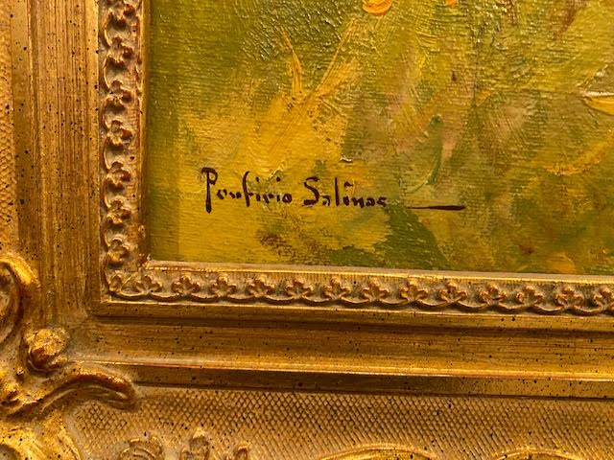

PROVENANCE.

So, over a period of about four years, I was able to pin down and document the provenance of the painting “Hill Country Summer” as follows:

1. 1938 – 1943, “Hill Country Summer” is painted by the artist, Porfirio Salinas.

2. Before 1948, the painting is purchased by University of Texas Law professor A.W. Walker from Porfirio Salinas.

3. 1948, the painting goes to the “Jackson Walker Law Firm” along with it’s owner A. W. Walker.

4. 2004 – 2005, the painting is purchased by “David Dike Fine Art” from the Jackson Walker Law Firm.

5. 2004 – 2005, the painting is sold by David Dike Fine Art to a Houston oncologist.

6. 2014, the painting is consigned by the Houston Oncologist to “Roughton Galleries” in Dallas, Texas.

7. August 25, 2014, the painting is purchased by Sam and Karen Pemberton from “Roughton Galleries”.

ADDITIONAL INFORMATION.

On the back of this painting is the original price written in pencil. $1000. This is in line with prices for 30 X 40, quality works, in the 1930’s and 1940’s. For comparison, Dawson Dawson Watson was selling his 30 X 40 exhibition quality oils in the 1926 to 1930 time period for $1200 to $1500.

There is writing in pencil on the back of the painting that says “Austin National Bank”. Whether there was a group of paintings placed on display for sale at the bank by Salinas or Dewey Bradford, or why this is on the back of the painting is unknown. I can not find any information.

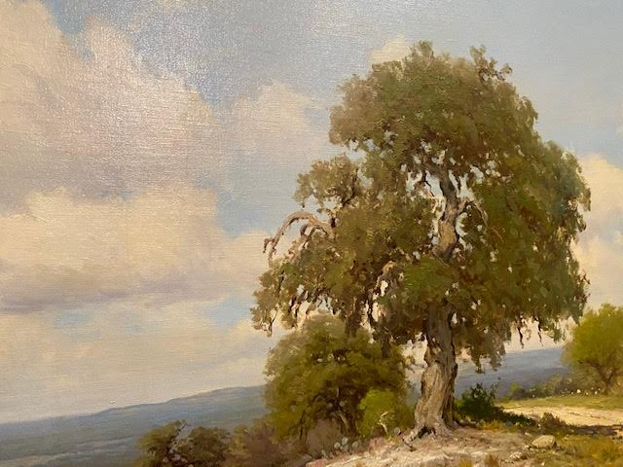

CONCLUSION AND COMMENT.

I will submit this information to CASETA (Center for the Advancement and Study of Early Texas Art) And for their archives. I believe it is important for owners of individual paintings to preserve the history and provenance information of their paintings for future owners and collectors.

I appreciate the help and information provided to me by all of those mentioned in this little paper.

Dated this 4th day of September, 2020

Sam Pemberton
shpkep@gmail.com
pembertonsam@hotmail.com,
281-704-9475

